
REPORT ON
THREE WEEKS OF INTERNSHIP
Carried out on
Survey on Electricity management and optimization of power consumption
Submitted to
NMAM INSTITUTE OF TECHNOLOGY, NITTE
In partial fulfillment of the requirements for the award of the Degree of Bachelor of Technology in Mechanical Engineering By

Nayak Jasveet Jayaram. Nishanth
(NNM24ME532) (NNM24ME533)

Navan Alva Mohana Poojary
(NNM24ME531) (NNM24ME530)
Mohammad Inshad (NNM24ME528)

Under the guidance Of
Dr. DIVIJESH P
Assistant Professor Gd III Department of Mechanical Engineering



CERTIFICATE

This is to certify that the “Internship Report” submitted by
Mr. NAVAN ALVA bearing USN NNM24ME528 of IVth semester B.Tech., a Bonafide student of NMAM Institute of Technology, Nitte, has undergone three weeks of internship about the topic Survey on Electricity management and optimization of power consumption. During September 2023-August 2024 fulfilling the partial requirements for the award of degree of Bachelor of Engineering in Mechanical at NMAM Institute of Technology, Nitte.

Name and Signature of Mentor Signature of HOD

Chapter No. | Title | Page.no
1 | Introduction | 04
2 | Survey Methodology | 05-06
3 | Key Findings on Consumption Patterns | 07-09
4 | Technology Adoption Trends in Electricity Management | 10-12
5 | Barriers to Optimization | 13-14
6 | Case Studies and Examples | 15
7 | Recommendations and Strategies for Optimization | 16-17
8 | Conclusion and Future Directions | 18

Chapter 1
Introduction
Electricity management is a cornerstone of modern sustainability efforts, affecting everything from economic output to environmental impact. As the global population continues to grow and urbanize, the demand for electricity surges, placing increased pressure on existing infrastructure. Proper electricity management involves optimizing consumption to reduce waste, minimize costs, and promote cleaner energy practices. This report synthesizes insights from a recent comprehensive survey, shedding light on consumption behaviors, adoption of smart technologies, and the challenges faced by different sectors. These insights are crucial for shaping future policies, guiding investments, and inspiring innovation in energy efficiency. The findings offer a snapshot of how residential, commercial, and industrial entities approach electricity usage and where the biggest opportunities for improvement lie. Ultimately, better electricity management contributes to energy security, reduces greenhouse gas emissions, and supports the global transition to a more sustainable energy future.
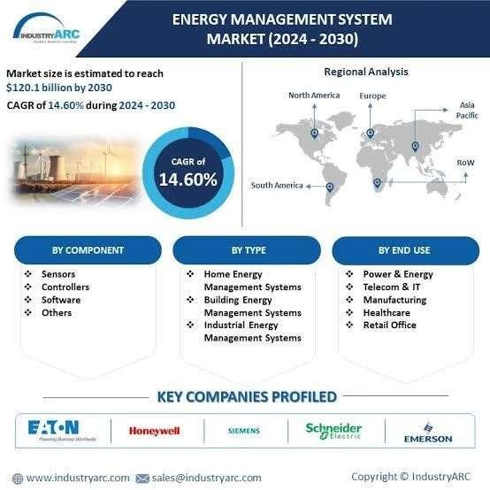

Chapter 2

Survey Methodology
The survey underlying this report was designed to capture a broad and detailed picture of electricity management across key user groups—residential, commercial, and industrial. A total of 1,500 participants responded to the survey, which included both quantitative questions (e.g., monthly consumption, peak usage times) and qualitative queries (e.g., perceived barriers, motivations for adopting new technologies). Participants were geographically diverse, spanning urban and rural areas to provide a balanced perspective. Data collection was carried out over a three-month period using digital and in-person methods, ensuring inclusivity and accuracy. The survey was structured to assess not only current consumption patterns but also user awareness, attitudes toward smart technologies, and willingness to invest in energy-saving solutions. The rich dataset allowed researchers to identify key trends and correlations, laying the foundation for the strategic insights presented in this report.

- Objective Definition

  - Clearly define the purpose of the survey (e.g., energy consumption patterns, load analysis, customer satisfaction, system losses).
  - Establish specific research questions or goals (e.g., reducing power wastage, improving billing accuracy).

- Target Population and Sampling

  - Identify the target group (households, industries, commercial users, etc.).
  - Choose appropriate sampling methods: random sampling, stratified sampling (based on region, type of consumer, etc.).
  - Ensure sample size is statistically significant to draw general conclusions.

- Questionnaire Design

  - Prepare structured questionnaires with both quantitative and qualitative questions.
  - Include sections on:
    - Energy usage habits
    - Appliance usage and efficiency
    - Awareness of energy-saving measures
    - Satisfaction with electricity services
  - Keep the language clear and unbiased.

- Data Collection Methods

  - Use appropriate data collection techniques:
    - In-person interviews
    - Telephonic surveys
    - Online forms or mobile apps
    - Smart meters and data loggers (for technical data)
  - Train surveyors to ensure consistency and accuracy.

- Field Survey Execution

  - Deploy trained personnel to gather data.
  - Monitor data collection process for quality assurance.
  - Use GPS or location tagging for large-scale area surveys.

- Data Analysis and Interpretation

  - Clean and validate the collected data.
  - Use statistical tools (Excel, SPSS, R, etc.) for analysis.
  - Analyze trends in consumption, load profiles, and peak demand patterns.
  - Identify high-loss areas or inefficient energy use sectors.

- Reporting and Visualization

  - Present findings through charts, tables, and graphs.
  - Summarize key insights and recommendations.
  - Compare results with previous surveys or benchmarks.

- Feedback and Policy Recommendations

  - Share results with stakeholders (government, utility companies, public).
  - Suggest improvements in infrastructure, billing systems, or awareness programs.
  - Use findings to shape energy conservation policies or tariff adjustments.

- Follow-Up and Monitoring

  - Plan periodic surveys to track changes over time.
  - Implement pilot projects based on survey results and monitor impact.

Chapter 3

Key Findings on Consumption Patterns
One of the most significant findings from the survey was the impact of user behavior on electricity costs and system efficiency. It was found that a large percentage of industrial users have shifted their high-energy operations to off-peak hours, resulting in reduced energy bills and more balanced grid loads. Residential users, on the other hand, often demonstrated inconsistent consumption patterns, with spikes occurring in the evening hours. Commercial entities frequently reported an awareness of peak-hour pricing but indicated a lack of flexibility in shifting operations due to business constraints. The data also revealed that seasonal variations and weather conditions strongly influenced residential usage, particularly for heating and cooling. These findings emphasize the need for tailored strategies for each sector to optimize consumption behavior and encourage practices that benefit both users and utility providers.
- Peak Demand Timing

  - Residential areas typically show peak consumption during morning (6–9 AM) and evening (6–10 PM).
  - Commercial zones peak during business hours (9 AM–5 PM).
  - Industrial usage is more stable but can peak during shift changes or high production periods.

Sector-Wise Consumption
  - Residential sector accounts for a significant portion of total consumption, often due to lighting, cooling/heating, and appliance use.
  - Industrial sector shows high base loads, with usage driven by machinery and processes.
  - Agricultural consumption spikes during irrigation seasons, typically using inefficient pumps.

High Energy Use Appliances
  - Air conditioners, heaters, refrigerators, and water pumps are the top contributors to electricity use.
  - Older or non-star-rated appliances consume significantly more energy than energy-efficient models.

Urban vs. Rural Patterns
  - Urban areas show more consistent and higher consumption, often due to lifestyle and appliance saturation.
  - Rural areas show seasonal or time-dependent usage, with limited appliance diversity.

Seasonal Variation
  - Summer months show increased electricity demand due to cooling (fans, air conditioners).
  - Winter may show increased usage in colder regions due to heating needs

Inefficiencies and Wastage

  - Poor maintenance of appliances and wiring leads to significant energy loss.
  - A lack of awareness about energy-saving practices results in unnecessary consumption.
  - In some areas, illegal connections or technical losses also affect net consumption figures.

Low Awareness of Energy Efficiency
  - Many consumers are unaware of star-rated appliances or practices like switching off idle devices.
  - Energy-saving behaviors are more common in educated or higher-income groups.

Impact of Smart Metering
  - Areas with smart meters show better awareness and control over usage.
O Consumers adjust behavior when provided with real-time usage data.

Billing and Consumption Mismatch
  - Several consumers report mismatch between perceived and billed usage, indicating issues with metering or billing accuracy.

Demand-Side Management Potential

  - Surveys reveal substantial scope for shifting or reducing demand via incentives, time-of-use pricing, and energy-efficient upgrades.

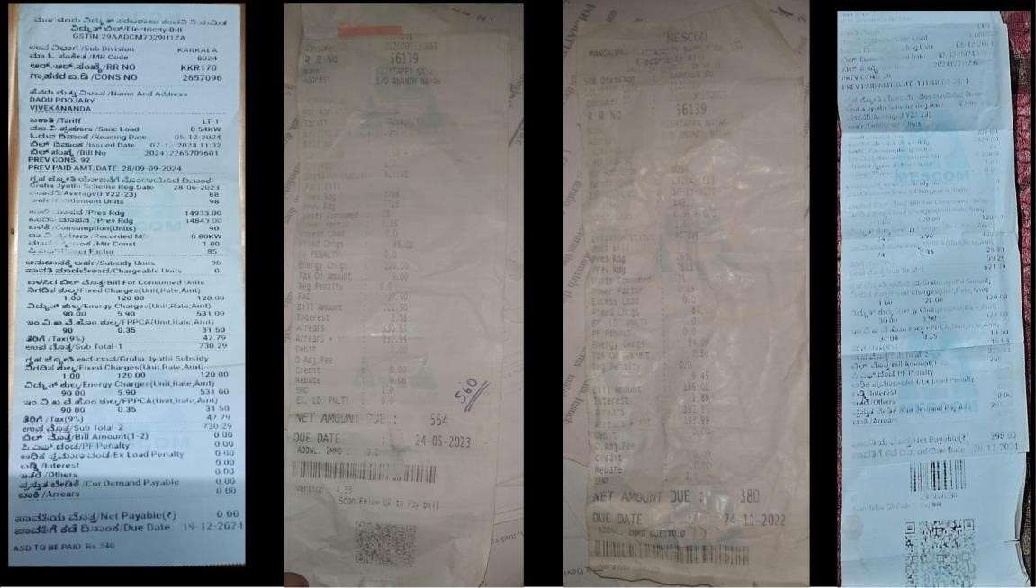

House .NO | RR . NO | Bill before (zero bill) in Rs | Bill after (zero bill) in ‘Rs’
1 | KRR170 | 260 | 720 ( after  deducting it’s ‘0’)
2 | 56139 | 160.21 | 560 ( 10 )
3 | ELL416 | 151.51 | 600.78(27)
4 | BL8335 | 149.68 | 670.90(2 )
5 | KP44389 | 485.42 | 1333.82(435)
6 | PAL635 | 102.05 | 292.25
7 | MA534 | 984.32 | 2365 (1009.14)
8 | KPMA51807 | 396.49 | 544.68(420.72)
9 | KLPR2193 | 460.76 | 1047.30(386)
10 | 9291 | 96.89 | 285(-5)

Chapter 4

Technology Adoption Trends
The transition to smart technology in electricity management is gaining momentum across all surveyed sectors. Smart meters, programmable thermostats, and comprehensive energy management systems were among the most commonly adopted tools. These technologies provide real-time insights into consumption patterns, allowing users to make informed decisions and detect inefficiencies. Industrial sectors lead in terms of adoption rate, driven by clear cost benefits and policy incentives. Commercial businesses are increasingly implementing automated lighting and HVAC systems that adjust based on occupancy and time of day. Residential users are slowly catching up, especially in regions where utility companies have made smart meters a standard feature. Despite this progress, challenges such as interoperability between devices and concerns about data privacy persist. Overall, the trend points toward a more connected and intelligent energy infrastructure.

Technology Adoption Trends in Electricity Management

Smart Meter Deployment
  - Enables accurate billing, remote monitoring, and demand-side Rapid increase in installation of smart meters for real-time tracking of electricity usage.

  - management.

  - Reduces manual meter reading errors and enhances transparency.

Renewable Energy Integration
  - Growing adoption of solar panels at residential and commercial levels.

  - Use of grid-tied and hybrid systems is rising in urban and rural electrification projects.

  - Net metering policies encourage consumers to feed excess solar power back into the grid.

Energy Management Systems (EMS)

  - Commercial and industrial sectors are adopting EMS to monitor and optimize power usage.

  - EMS includes automation, usage analytics, and alert systems for abnormal consumption.

Home Automation and IoT

  - Rising use of smart plugs, thermostats, and lighting systems controlled by mobile apps or voice assistants.
.
  - Helps consumers manage power consumption more efficiently and remotely.

Electric Vehicles (EVs) and Charging Infrastructure

  - Increasing EV adoption drives demand for smart charging stations.

  - Load balancing technologies are being introduced to manage EV-related electricity demand.

Demand Response Systems

  - Utility companies are implementing demand response programs to shift or reduce load during peak hours.

  - Consumers are incentivized to reduce usage during high-demand periods.

AI and Data Analytics

  - AI and machine learning are used to predict load patterns, detect faults, and optimize distribution networks.

  - Utilities use analytics for proactive maintenance and planning.

Blockchain in Energy Trading

O Emerging use of blockchain for peer-to-peer energy trading and decentralized energy exchanges.

  - Supports secure and transparent transactions between producers and consumers.

Battery Storage Systems

  - Increasing use of battery backup systems, especially in areas with unreliable supply.
- Facilitates peak shaving and improves grid reliability in conjunction with solar systems.

Mobile and Online Platforms

  - Most utilities now offer mobile apps or portals for bill payment, consumption tracking, and complaint registration.
  - Enhances customer engagement and service delivery.

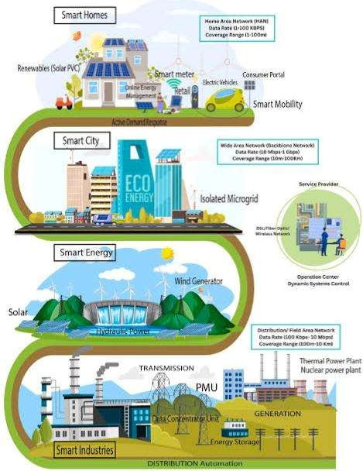

Chapter 5

Barriers to Optimization
Despite the promising advancements in energy-saving technologies, several barriers hinder widespread adoption and optimization. Foremost among these is the high initial cost of installation, which deters especially small businesses and lower-income households. Many survey respondents indicated a lack of awareness about available technologies or how to use them effectively. Infrastructure limitations, particularly in rural or underdeveloped areas, also pose significant challenges. Additionally, there is often resistance to change, driven by concerns over potential disruptions to business operations or lifestyle. Regulatory hurdles, such as outdated energy policies and limited incentives, further complicate the adoption process. These barriers highlight the need for targeted education, financial support mechanisms, and policy reform to facilitate smoother transitions to more efficient energy use.

Barriers to Optimization in Electricity Management

Lack of Awareness
  - Many consumers are unaware of energy-saving practices, efficient appliances, or the long-term benefits of optimization.
  - Limited public knowledge about demand-side management or energy audits.

High Initial Investment Costs 3.
  - Energy-efficient technologies (like smart meters, solar systems, EMS) require upfront costs that deter adoption.
  - Small businesses and low-income households often cannot afford these investments despite long-term savings

Inadequate Infrastructure
  - Aging or poorly maintained transmission and distribution networks lead to technical losses.
  - Limited access to smart grids, automation, and communication infrastructure in rural and remote areas.

Regulatory and Policy Gaps
O Absence of strong enforcement of energy efficiency standards.
O Lack of incentives or subsidies for optimization-related technologies or practices.

Resistance to Change
  - Consumers and utilities often resist shifting from traditional systems to newer technologies.
  - Fear of disruption, unfamiliarity, or lack of technical training contributes to inertia.

Data Limitations
  - Inaccurate, outdated, or insufficient consumption data makes it hard to identify inefficiencies or plan improvements.
  - Lack of smart metering limits real-time data collection and monitoring.

Skilled Manpower Shortage
  - Shortage of trained personnel for installation, maintenance, and management of optimization technologies.
  - Utilities may lack skilled engineers to interpret data and implement energysaving strategies.

Intermittency of Renewables
  - Integration of solar or wind power introduces variability, complicating load balancing and grid stability without proper storage or forecasting tools.

Consumer Behavior
  - Habitual energy use patterns, like leaving devices on standby or overusing appliances, hinder optimization.
  - Energy-saving behavior is often deprioritized in favor of convenience or comfort.

Fragmented Stakeholder Coordination
  - Lack of coordination between policy makers, utilities, technology providers, and consumers.
  - Optimization efforts often remain isolated or poorly implemented without a unified strategy.

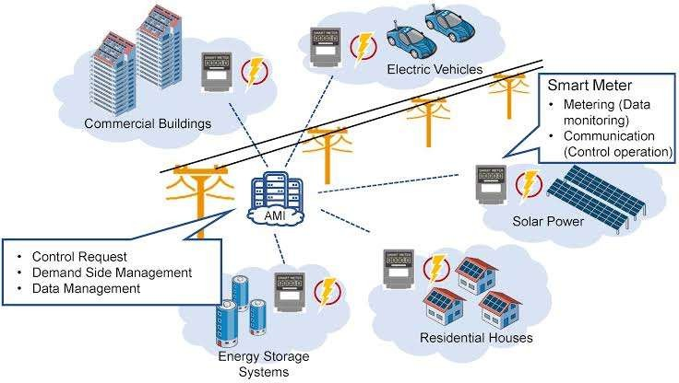

Chapter 6

Case Studies and Examples
Real-world examples from the survey illustrate the tangible benefits of adopting energyefficient practices. A medium-sized commercial business in an urban center reported a 30% reduction in electricity bills after implementing an automated lighting and HVAC system. Another case involved a residential community that participated in a pilot smart meter program, resulting in a 15% drop in energy consumption within six months. In the industrial sector, a manufacturing plant integrated an advanced energy monitoring system that identified previously unnoticed inefficiencies, saving them thousands of dollars annually. These cases underline the practical value of smart technology and informed energy management. They also demonstrate that with the right tools and support

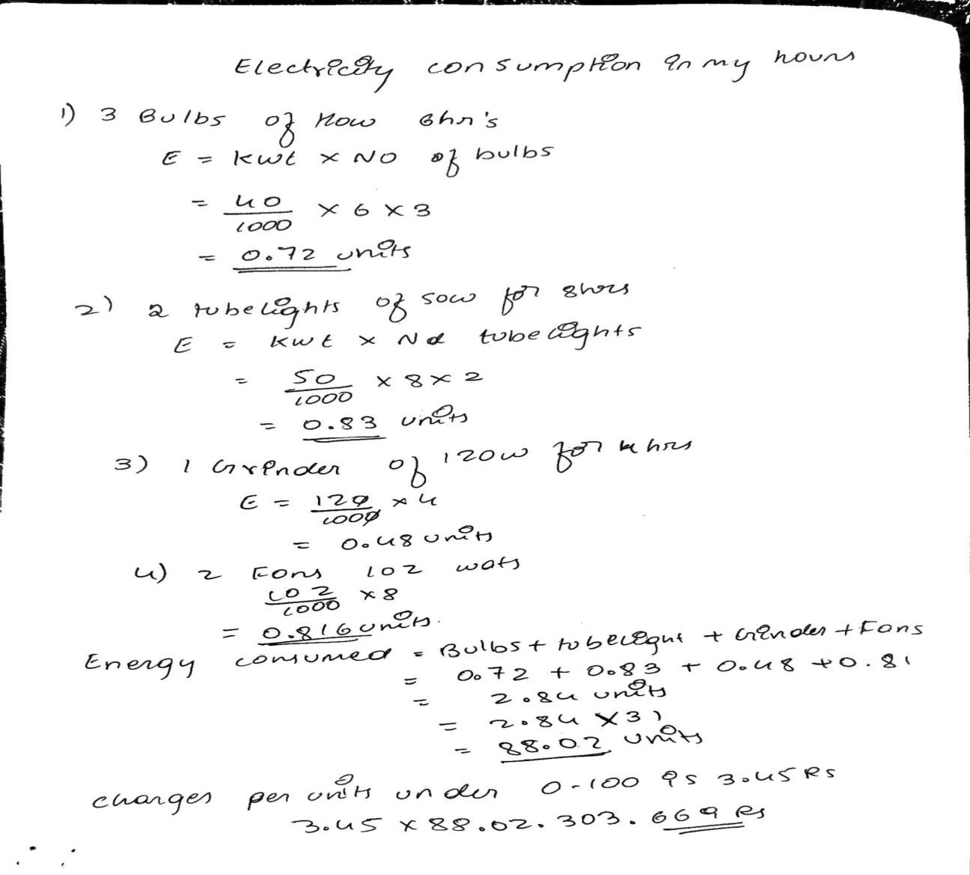

Chapter 7

Recommendations and Strategies
To address existing barriers and promote optimized electricity management, a multipronged approach is required. Policymakers should consider offering subsidies or tax credits for businesses and households investing in energy-saving technologies. Public awareness campaigns can educate consumers about the long-term benefits and operational ease of smart systems. Utility companies should invest in infrastructure upgrades, particularly in underserved areas, to support widespread adoption. Partnerships between private companies, government agencies, and educational institutions can also foster innovation and accelerate deployment. Standardizing equipment and ensuring interoperability among systems can further streamline adoption. Ultimately, sustained progress depends on coordinated action across all levels—government, industry, and individual consumers.

Recommendations and Strategies for Optimization in Electricity Management

Promote Energy Awareness Campaigns
  - Launch educational programs to inform the public about energy-saving habits, efficient appliances, and cost-saving benefits.
  - Use schools, community centers, media, and utility bills as platforms for outreach.

Encourage Adoption of Smart Technologies
  - Subsidize or incentivize the use of smart meters, home automation, and energy-efficient appliances.
  - Mandate smart meter installation for new connections or large consumers.

Implement Energy Audits
  - Make regular energy audits compulsory for industrial and large commercial users.
  - Provide support for small and medium enterprises (SMEs) to assess and improve energy performance.

Strengthen Policy and Regulatory Framework
  - Enforce building energy codes and appliance efficiency standards (e.g., star ratings).
  - Introduce time-of-use pricing to encourage off-peak consumption and reduce peak load.

Upgrade Infrastructure
  - Invest in modernizing the grid, reducing technical losses through automation, better conductors, and improved transformers.
  - Expand deployment of smart grids and integrate real-time monitoring systems.

Develop Demand-Side Management (DSM) Programs
  - Design incentives for consumers to shift usage during off-peak hours.
  - Collaborate with large consumers to implement load management and demand response programs.

Renewable Energy and Storage
  - Facilitate easier access to solar panel installations with net metering policies.
  - Promote community solar projects and incentivize use of battery storage systems.

Enhance Data Collection and Usage
  - Use data analytics to identify peak usage trends, detect inefficiencies, and forecast demand.
  - Create centralized databases to support planning and decision-making by utilities and regulators.

Capacity Building and Training
  - Train utility staff and technicians in modern energy management tools and best practices.
  - Establish partnerships with academic institutions for research and skill development.

Foster Stakeholder Collaboration
  - Promote coordinated action among government, utilities, private sector, and consumers.
  - Encourage public-private partnerships (PPPs) for investment and innovation in energy efficiency projects.
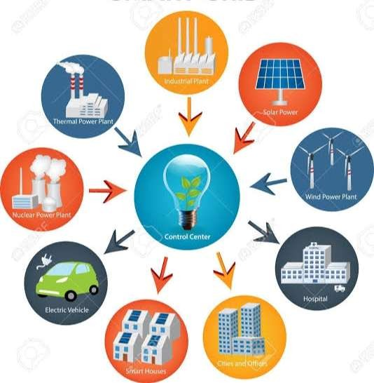

Chapter 8

Conclusion and Future Directions

Here we are concluding our report on the serve on “Electricity management and optimization of power consumption” , The people are using the electricity unnecessary due to the government free electricity bill ,We have attached the usage of electricity before and after the free sceam, people don’t know how electricity is produced and the risks behind so we created a small model to explain it Over goal was to create awareness among people
